**IGCSE papers**

* The theory paper was harder than the other papers for me. Most students score higher on practical papers but need help with theoretical papers. Here are some tips for the theoretical paper: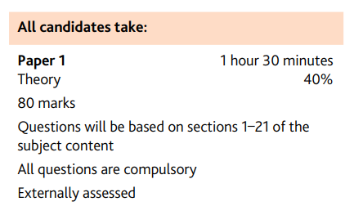
* Make notes for each chapter. Understanding every single chapter is important. Making notes helps you to memorize it and will be easy to refresh and confirm your knowledge before the exam.
* Learn the examples. To score higher in theoretical questions you should give examples in your answers.
* Do many past paper practices as much as possible. Past paper questions are generally similar and some of the questions are repeated. So practicing past papers is the most important and effective way to prepare for theoretical papers.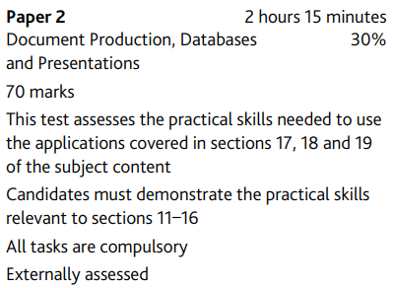
* As mentioned before, most students are likely to score higher on the practical papers. Here are some tips :
* Learn fundamental skills for each application. The teacher will give you step by step guide to help you with using the applications or you can use youtube.
* Do many past paper practices as much as possible. By practicing enough on practical papers, it will help you to be less nervous during the exam.
* Watch YouTube and follow. If it is challenging for you to practice past papers by yourself. Search the paper on YouTube and follow the steps. After practicing by following those videos, it will be much easier to practice alone and pass your exam successfully. (Those Indian guys on YouTube are helpful)

